How to make modern stenography step-by-step

**Step 1 :** Choose a big sized image.

Here is mine

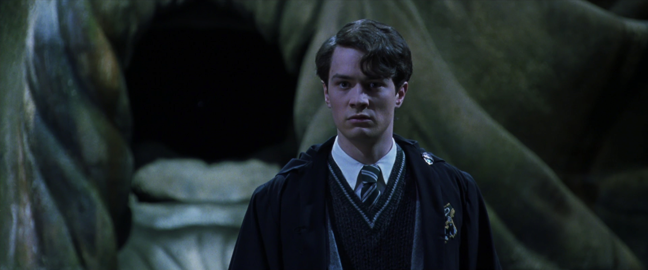

**Step 2 :** Log in to <https://stylesuxx.github.io/steganography/>.

**Step 3 :** Load your visual.

**Step 4 :** Type your message in “I am Voldemort.”.

**Step 5 :** Click on Encode

**Step 6 :** Download the image containing the hidden message (third one) and if needed, copy the binary representation of your message.

